EASTERN AFRICA STATISTICAL TRAINING CENTRE
DSU07210 — Linux Systems Administration
Group Assignment Submission Template
Data Science Year 1 | Academic Year 2025/2026

A. Group & Assignment Information

Group & Assignment Details
Assignment No. | 04 | Session | C
Assignment Title | Linux Systems Administration
Group No. | 10 | Date Submitted | 7th June 2026
Academic Year
2025 / 2026

B. Group Members
List all group members. The Role/Task column should show which task(s) each member led.

# | Full Name | Reg. Number | Session | Role / Task
1 | FREDY RESPICHIUS MATUNGWA | EASTC/BDTS/26/04195 | 10 C | Lab supervisor
2 | TEKLA JOHN MKUDE | EASTC/BDTS/25/02469 | 10 C | Screenshots and quality control
3 | MARIA AGUSTINO KIKOTI | EASTC/BDTS/26/04694 | 10 C | Quality control& screenshot
4 | GLORY PETER SALUM | EASTC/BDTS/26/04583 | 10 C | Lead technical writer
5 | KELVIN EMANUEL SILVESTA | EASTC/BDTS/26/01903 | 10 C | Terminal operator
6

C. Assignment Instructions Summary
Before starting, re-read the full assignment from your lecturer. Then tick the boxes below as you complete each task.

- Every command must be run on a real Linux terminal.
- Screenshots or terminal recordings are required as evidence.
- Complete the Creativity Challenge with a scenario your group designs.
- Each member completes the Self-Exploration section individually.
- Submit this template as your group report (printed or PDF).

D. Task Completion Checklist
For each task: briefly describe what your group did, mark whether it is complete, and note the evidence (e.g. screenshot filename or page number in your terminal log).

# | Task Description (summarise what you did) | Done? (Yes/No) | Evidence
1 | Firstly we run a long-running process in the background called ( sleep 300) and use ps command to find the process PID | Yes | 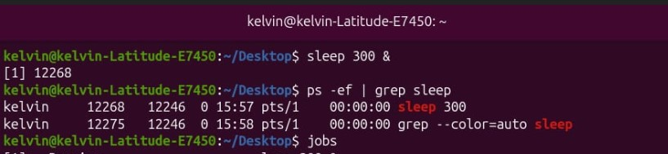  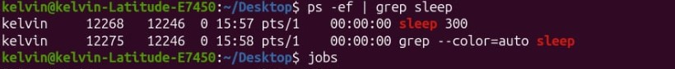  Hence PID values: [1] 122268
2 | As group wer use jobs command to list background jobs and bring one to the foreground using command fg | Yes | 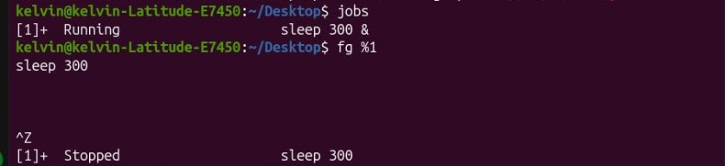
3 | We launch top and identify the process consuming the most CPU – and by that we take a screenshot | Yes | 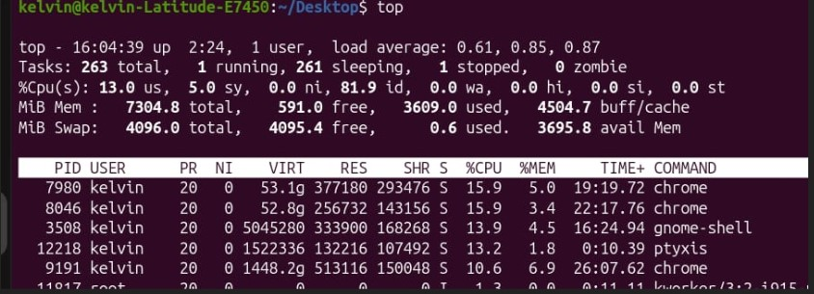  Hence the top consumption process are:  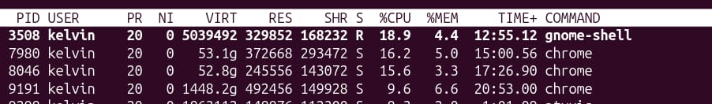  - Grone-shell 18.9%  - Chome 16.2%  - Chrome 15.6%
4 | By using kill command we terminate a process by both PID but also by name | Yes | 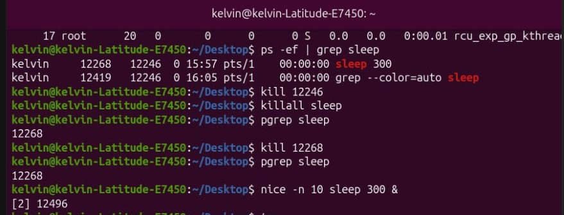
5 | We run command with nice –n 10 and kindly we folloup how it appear in top | Yes | 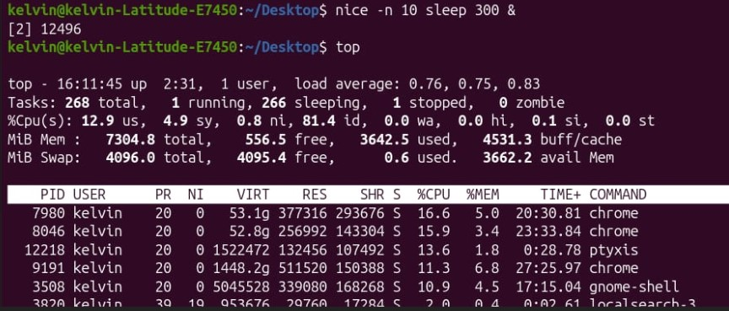

E. Command Evidence Log
Record the key commands your group ran. Attach screenshots after this page or include terminal output in an appendix.

# | Task Ref. | Command(s) Run / Description | Screenshot?
1 | Task 1 | Command: sleep 300  ( Start a long-running process in the background)  Ps –ef | grep sleep  (List running process to find the PID of the sleep command ) | 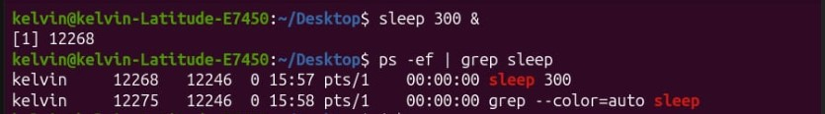
2 | Task 2 | Command: jobs  ( list all current active background jobs on the sytems)  fg %1  (Used to brong background number 1 to the foreground) | 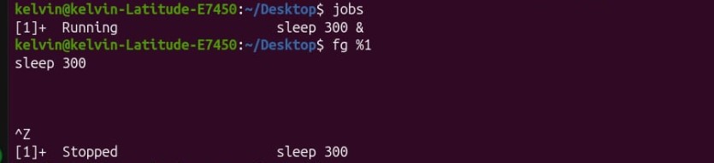
3 | Task 3 | Command: top  (launches the interactive process monitor to the identify the highest CPU-cunsuming process | 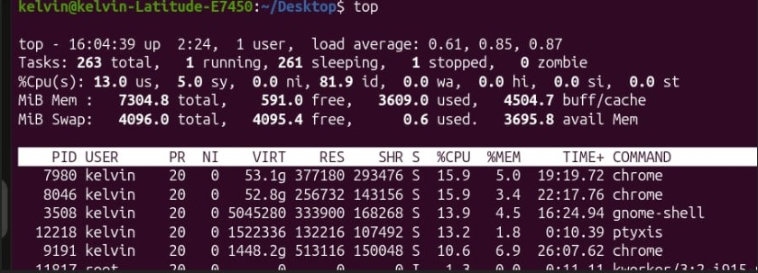
4 | Task 4 | Command: kill 122246  ( terminate all running process using its process ID-PID)  Killall sleep  ( Terminate all runnimg instances of thr process by name) | 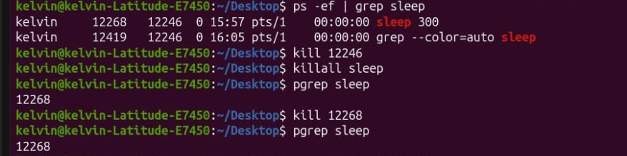
5 | Task 5 | Command : nice –n 10 sleep 500  (launches a new process with an altered/reduced priority level) | 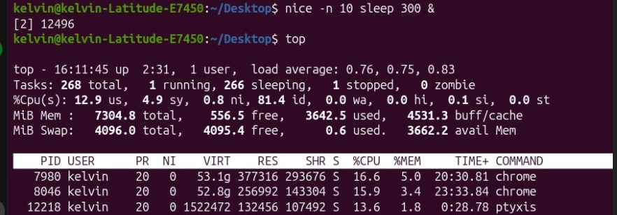
6
7
8

F. Creativity Challenge
Describe the real-world scenario your group chose and explain your creative design decisions.

Creativity Challenge
Scenario we chose:

Our creative approach:

G. Self-Exploration (Individual — one per member)
Each group member must complete their own copy of this section. Photocopy this page or attach separate sheets — one per member.

Student Name: ________________________________ Reg. No.: ___________________________

Self-Exploration Findings
Exploration question answered:

Key commands tested:

What I discovered:

H. Group Member Contributions
Briefly describe what each member contributed. The percentages must add up to 100% per task (or you can distribute overall contribution).

Member Name | Specific Contribution | % Contribution
FREDY RESPICHIUS MATUNGWA | Running Task 1 & code verified | 20%
TEKLA JOHN MKUDE | Running task 2 | 20%
MARIA AGUSTINO KIKOTI | Running task 3 | 20%
GLORY PETER SALUM | Runing Task 4 and write a report | 20%
KELVIN EMANUEL SILVESTA | Running Task 5 and take screenshots,leadt Technical writer | 20%
J. Declaration
We declare that this is our own group work. All commands were run on a real Linux system. All members participated as recorded above. We have not copied work from another group.

Group Leader Signature:

Date: ____________________________

EASTC | DSU07210 Linux Systems Administration | 2025/2026

